Name : S.Akilarasi
Reg no: 192512426

Ex No 6 : 5G NR Frame Structure Analysis with Different Subcarrier Spacing
Aim : To analyze the 5G NR frame structure by studying the effect of different subcarrier spacings, slot durations, and OFDM symbols using MATLAB.
Objectives
1. To analyze different Subcarrier Spacing (SCS) values used in 5G NR numerology.
2. To compare the slot duration corresponding to different Subcarrier Spacing values in 5G NR.
3. To study the number of OFDM symbols present in a 5G NR slot for normal cyclic prefix.
Procedure:
clc; clear; close all;
Ps = 1;
Pn = [0.1 0.05 0.01]; % Signal Power (W) % Noise Power (W)
Users = 1:3; SNR = 10*log10(Ps./Pn); % SNR in dB
disp('User Noise Power(W) SNR(dB)')
disp([Users' Pn' SNR'])
figure
bar(Users,SNR,"black")
xlabel('Users')
ylabel('SNR (dB)')
title('Signal-to-Noise Ratio of FDMA Users')
grid on

Output:
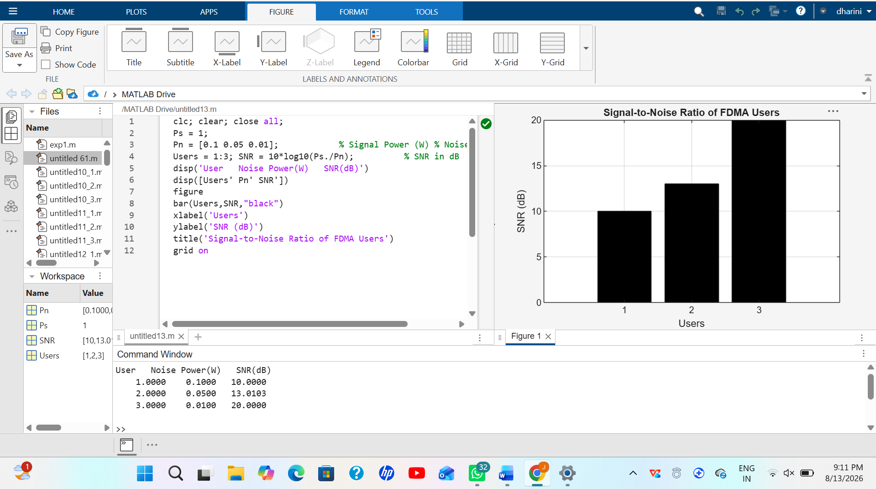
Objective 2:
clear;
close all;
scs = [15 30 60 120 240]; % Subcarrier Spacing (kHz)
slot = [1 0.5 0.25 0.125 0.0625]; % Slot Duration (ms)
plot(scs, slot, 'o-', 'LineWidth', 2,'Color','m')
grid on
xlabel('Subcarrier Spacing (kHz)')
ylabel('Slot Duration (ms)')
title('192512216 5G NR Slot Duration for Different Subcarrier Spacing')

Output:
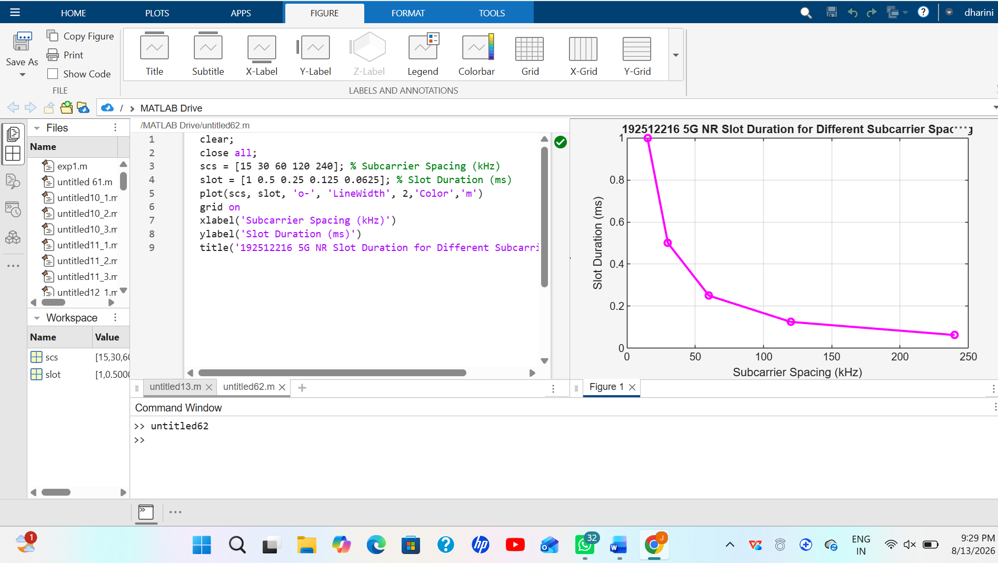
Objective 3:
clc;
clear;
close all;
scs = [15 30 60 120 240]; % Subcarrier Spacing (kHz)
symbols = [14 14 14 14 14]; % OFDM Symbols per Slot
figure
b = bar(scs,symbols);
b.FaceColor = 'm'; %Changes
grid on
xlabel('Subcarrier Spacing (kHz)')
ylabel('Number of OFDM Symbols')
title('192512216 OFDM Symbols per Slot for Different Subcarrier Spacing')
ylim([0 16])
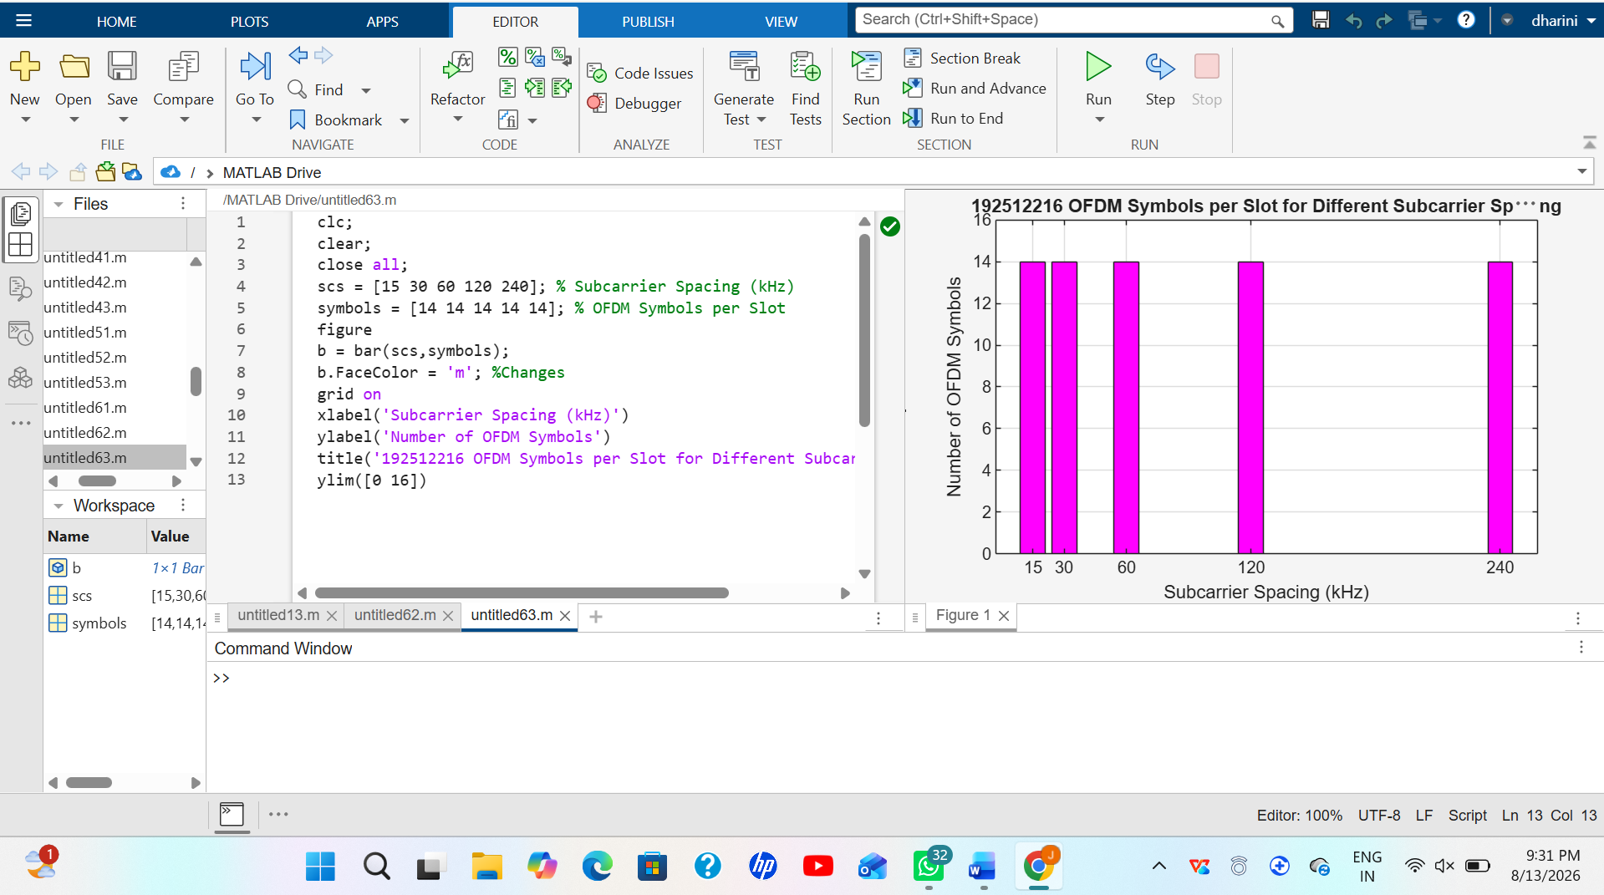Output:

Result : The MATLAB analysis successfully demonstrated the flexible numerology of 5G NR. The results showed that increasing the subcarrier spacing decreases the slot duration while maintaining a constant number of OFDM symbols per slot under the normal cyclic prefix configuration.

